Angular 7 Features (31st October 2018)
1.Cliprompts
Now the CLI responds with prompts. Simply try ng new myangular7app and what do you get? A brand new prompt asking if you would like to add routing or not?. Want to try a different stylesheet format? Don't worry. The CLI will let you select between CSS, SCSS, SASS and LESS. And the great news, it's customizable! Add a schematic.json using the Schematic CLI and you can tell the Angular CLI which prompts to execute.

"routing": {
"type": "boolean",
"description": "Generates a routing module.",
"default": false,
"x-prompt": "Would you like to add Angular routing?"
},

2. Angular Material and CDK added

3. ScrollingModule
As many mobile frameworks have started to make the move toward dynamically loading data such as images or long lists, Angular has followed suit by adding the ScrollingModule to allow for virtual scrolling. As elements gain or lose visibility, they are virtually loaded and unloaded from the DOM. Performance is greatly increased to the user's eyes. Next time you have a potentially large list of items for your users to scroll, stick it in a cdk-virtual-scroll-viewport component and take advantage of the performance boost!

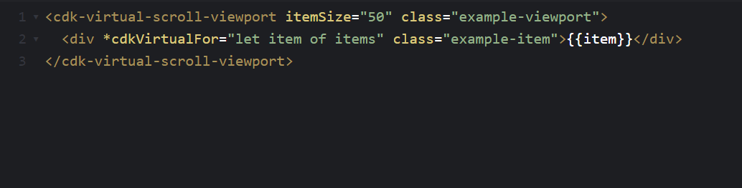

4. DragDropModule
Now you can remain entirely within the Angular Material module and implement drag and drop support including reordering lists and transferring items between lists. The CDK includes automatic rendering, drag handlers, drop handlers and even the ability to transfer data. Don't like the standard drag animation? No sweat. It's Angular; it's yours to override.

Drag and drop support is now in the CDK and includes automatic rendering as the user moves items and helper methods for reordering lists (moveItemInArray) and transferring items between lists (transferArrayItem).

<div cdkDropList class="list" (cdkDropListDropped)="drop($event)">
<div class="box" *ngFor="let movie of movies" cdkDrag>{{movie}}</div>
</div>

drop(event: CdkDragDrop<string[]>) {
moveItemInArray(this.movies, event.previousIndex, event.currentIndex);
}
5. Application Performance
Angular 7 is even faster than previous versions. The upgrade is faster (less than 10 minutes for many apps according to the official announcement), the framework is faster, the virtual scrolling CDK module detailed above makes apps run with better performance.

They've corrected a common production mistake where the reflect-metadata polyfill is included in production. V7 automatically removes it.

New projects are also now defaulted using Budget Bundles which work to notify you when your app is reaching size limits. By default, you get warnings when you reach 2MB and errors at 5MB. And when you need a little more space, just jump in your angular.json and adjust as necessary.

"budgets": [{
"type": "initial",
"maximumWarning": "2mb",
"maximumError": "5mb"
}]

6.Updated Dependencies
Angular is up to Typescript 3.1, RxJS is up to 6.3 and Node 10 support has been added!

7. Ivy Renderer
Ivy is currently under active development and is not part of the v7 release. We are beginning to validate the backwards compatibility with existing applications and will announce an opt-in preview of Ivy as soon as it is ready in the coming months.

8.Updates are become easy now
ng update @angular/cli @angular/core
ng update @angular/material

9. Improved Accessibility of Selects
Improve the accessibility of your application by using a native select element inside of a mat-form-field. The native select has some performance, accessibility, and usability advantages, but we’re keeping mat-select which gives full control of the presentation of options.

10. Angular Elements
Angular Elements now supports content projection using web standards for custom elements.

<my-custom-element>This content can be projected!</my-custom-element>
11. Partner Launches
Angular owes a huge amount of its success to the community, and to that end we’ve been working to partner with several community projects that have launched recently.
- Angular Console — A downloadable console for starting and running Angular projects on your local machine
- @angular/fire — AngularFire has a new home on npm, and has its first stable release for Angular
- NativeScript — It’s now possible to have a single project that builds for both web and installed mobile with NativeScript
- StackBlitz — StackBlitz 2.0 has been released and now includes the Angular Language Service, and more features like tabbed editing

